Needs Statement:

REACH of Macon County provides the only shelter for domestic and sexual violence victims and their children for both Macon and Jackson counties. This is the closest domestic or sexual violence emergency shelter in more than 45 minutes east or west of Macon County.

Since September 1990, REACH’s existing shelter has been located in an older farmhouse that is owned by the Baptist Children’s Home. The existing shelter only provides REACH with six bedrooms for victims of domestic and sexual violence and their children, which is not enough space to meet our current demands. Over a period of 31 months (2 ½ years), the shelter has been at 100% capacity for a period of seventeen months. During those times, we have been forced to turn victims away due to a lack of space.

During 2012-2013, REACH of Macon County provided a total of 1459 nights of shelter, or 121 nights per month. They also provided approximately 4377 meals annually or 363 meals per month. Statistics for the last six months indicate that we are projected to almost double these figures.

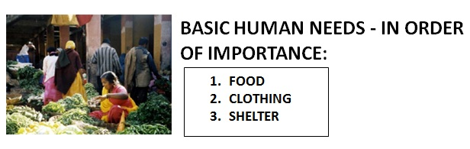

The current shelter does not have the adequate space in either bedrooms or common areas to meet our growing needs. The current facility has two washers and two dryers as well as only 3 bathrooms, which do not meet the demand of serving as many as 20 plus individuals or 6 families. Additionally, the kitchen area also has very limited dry and refrigerator storage space which impacts our agency and clients’ ability to safely store food needed for residents.

Finally, the current shelter is located 7 miles outside of our town area. The closest grocery store is 8 miles, the hospital is 7 miles, and the closest day care facility is about 8 miles. Our only public transit is by appointment only, which prioritizes medical appointments, and is very limited in its hours of operation. Therefore, transportation is a major challenge facing clients when living so far from services, resources, and employment.

